Creating the UML Model
The SDK Code Generator is based upon a Model-Driven Architecture (MDA) which supports the implementation of the following scenarios specified via a UML model:
- Modeling of object classes and a data model tables
- Modeling of class associations, including:
  - Uni- and bi-directional associations;
  - Many-to-Many, Many-to-One, One-to-Many, and One-to-One associations;
  - Associations that use a Join Table;
  - Associations that don’t use a Join Table;
- Modeling of inheritance that is implemented using:
  - One table per class
  - One table per hierarchy
  - One table per hierarchy, with a separate table for leaf-level child classes
- Mapping of data model tables to the object model classes
- Mapping of a table column to an object model attribute, including :
  - A simple (primitive) attribute, such as an integer or string;
  - A collection of simple (primitive) attributes; and,
  - An identifier attribute that is named something other than the default (ID) in the Logical (Object) Model.

The SDK distribution provides a sample model that demonstrates how these scenarios, and many others, can be modeled in a manner that is understood by the SDK Code Generator. The sample model is intended to be used as a reference when creating your own model. The sample model is located within the \models directory of the SDK distribution, and has been implemented in both Enterprise Architect and ArgoUML. The name of the sample model project file is, respectively:
- Enterprise Architect: SDKTestModel.EAP
- ArgoUML: sdk.uml
The following sections describe how to perform various modeling activities using both the Enterprise Architect (EA) and ArgoUML modeling tools.

Creating a New Project
To create a new object model project file, follow these steps:
- In EA, open the SDKEATemplate.EAP baseline file provided in the \models directory of the SDK distribution. This file already contains the base Logical View, Data Model, and Logical (Object) Model packages, as well as classes representing the wrapper Java primitive type classes, as shown below:
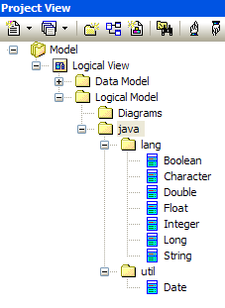
Figure 1 EA Project View Browser
In ArgoUML, open the SDKArgoTemplate.EAP baseline file provided in the \models directory of the SDK distribution. This file already contains the base Logical View, Data Model, and Logical (Object) Model packages, classes representing the wrapper Java primitive type classes, Tag Definitions (TD) for all the possible Tag Value types, and DataTypes as shown below:
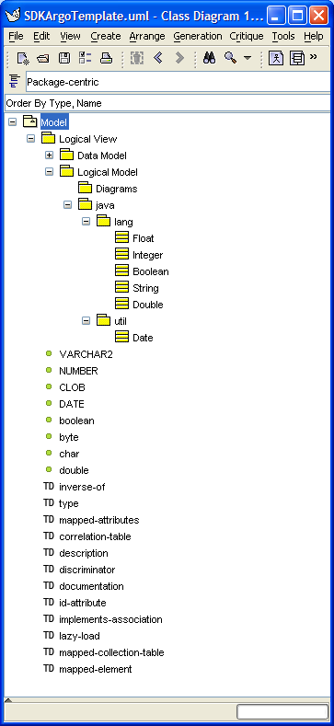
Figure 2 ArgoUML Explorer Pane Showing Packages/Classes, Tag Definitions, Data Types
- Select the File | Save Project As option.
- In EA, the Save Enterprise Architect Project dialog will appear, as shown below:
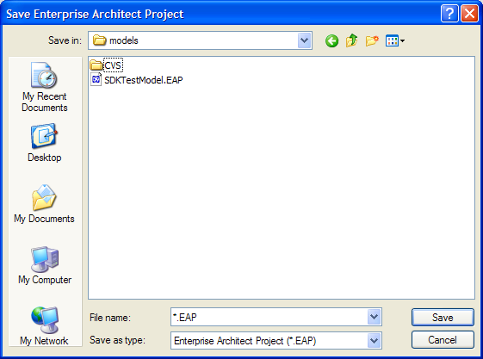
In ArgoUML, the Save Project dialog will appear, as shown below:
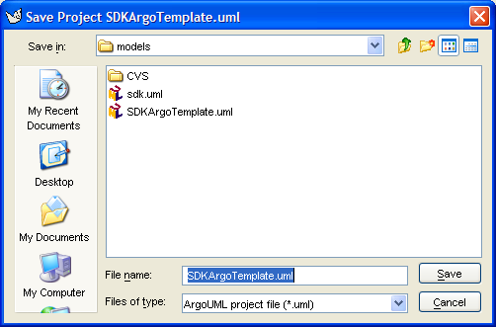

- Enter a new project name in the File name field.
- Click the Save button.
Alternatively, either of the baseline template files, SDKEATemplate.EAP or SDKArgoTemplate.uml, can be copied and renamed.
The new project file is now ready for use in creating the object and data model.

Creating Classes/Tables
UML Class elements are used to represent both Logical (object) Model classes and Data Model classes (tables). Object classes are typically created using a package hierarchy within the Logical Model package, while Data Model classes (tables) are created directly within the Data Model package without the use of a package hierarchy.

Creating a Logical Model Package Structure
To add a package structure to the Logical Model, follow these steps:
- In EA, select the Logical Model package, as shown below:

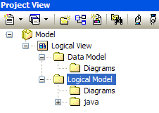
Figure 3 EA Project Browser
In ArgoUML, select the Logical Model package, as shown below:
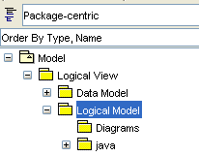
Figure 4 ArgoUML Explorer Pane
- In EA, right click and select the Add | Add Package menu OR go to the Project | Add Package submenu.
In ArgoUML, right click and select the Add Package menu option.
- In EA, The following dialog will appear, as shown below:
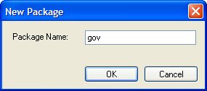
Figure 5 EA New Package Dialog
In ArgoUML, the Properties tab in the Detail pane will become active for the new package, as shown below:
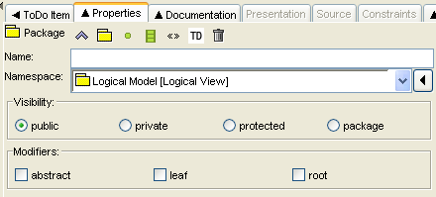
Figure 6 ArgoUML Package Detail Pane, Properties Tab
- In EA, enter a package (folder) name, and then click OK.
In ArgoUML, click the Save Project icon on the menu bar, or, alternatively, the Ctrl-S keys.
NOTE:  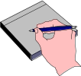 | Package names should follow Java package naming conventions; i.e., Java packages are defined using a hierarchical, lowercase, naming pattern, with levels in the hierarchy separated by periods (.) . Furthermore, package names are typically the organization’s domain name backwards. An example, taken from the SDK sample model, is gov.nih.nci.cacoresdk.domain.  When implemented within EA, each period designates the end of one package level, and the start of a new package level (termed a subpackage). Each package/subpackage needs to be created individually. I.e., no period(s) should be used when specifying a package name in the New Package dialog. Thus the fully qualified package gov.nih.nci.cacoresdk.domain requires a total of five (5) packages to be created within the model, one for each of the package levels. Each package is nested within the higher level one.

- Repeat steps 2-4 until the fully qualified package hierarchy has been created. To create a package within another package (as a sub-package/folder), select the existing package first, and then follow steps 2-4 above. The following diagram (EA only) shows most of the package hierarchy created in this manner for the SDK sample model:
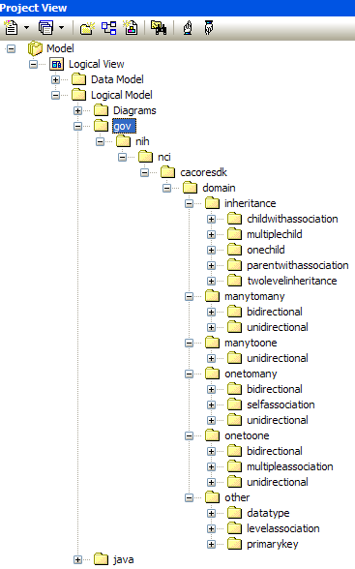
Figure 7 EA SDK Sample Model Packages

Creating a Logical (Object) Model Class
To add a Logical Model class to a package, follow these steps:
- In the EA Project Browser, or the ArgoUML Explorer pane, select the desired Logical Model package to which the class should be added.
- In EA, right click and select the Add | Add Element menu OR go to the Project | Add Element submenu.
In ArgoUML, new classes are added in the context of a class diagram within the selected package. If need be, click on a class diagram within the package to open/activate it, or create a new class diagram within the package if none exists. Select the 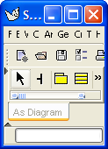New Class icon found at the top of the diagram Editing pane then draw a new class within the diagram. This will effectively create a new class within the selected package. Alternatively, click on an existing class within the selected package. The Property tab of the Detail pane will display the properties for the selected class. It will also display the New Class icon. Click on this icon.
- In EA, the Insert New Element dialog will appear, as shown below:
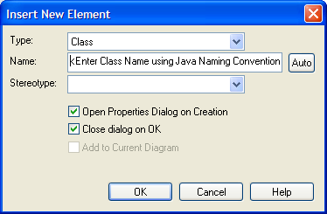
Figure 8 EA Insert New Element Dialog
In ArgoUML, the Properties tab in the Detail pane will become active for the new class, as shown below:
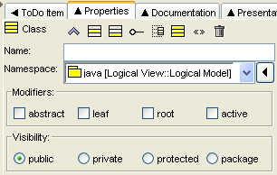
Figure 9 ArgoUML Class Detail Pane, Properties Tab
- In EA, set the Insert New Element options as follows:
Insert New Element Option | Description
Type | Select Class as the element type from the drop down list.
Name | Enter a class name according to the Java class naming conventions; i.e., class names should start with a capital letter, with embedded words capitalized.
Stereotype | Leave blank for Logical (object) Model classes.
Open Property Dialog | Check the Open Property Dialog option if you want the Property dialog to open immediately after the class is created.
Close dialog on OK | Uncheck the Close dialog on OK option if you want to add multiple classes in one session.

NOTE: | Logical (Object) Model class names should follow Java class naming conventions; i.e., class names should start with a capital letter, with embedded words capitalized. Here’s an example from the SDK sample model: GraduateStudent.
In ArgoUML, enter a class name in the Name field according to the Java class naming conventions; i.e., class names should start with a capital letter, with embedded words capitalized. Next, select the desired package where the class should be created from the Namespace drop down.
- In EA, click OK. If the Open Property Dialog was checked, the Property dialog will open up immediately after the class is created. The Property dialog for the SDK sample Credit class is shown below (EA). Note that the Stereotype field is blank since this class represents a domain object, and not a data table:
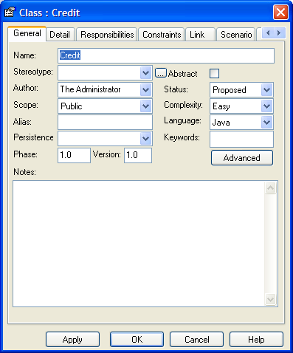
Figure 10 EA Class Property Dialog
In ArgoUML, click the Save Project icon on the menu bar, or, alternatively, the Ctrl-S keys.
See section 1.3 Creating Attributes and Data Types for instructions on how to add attributes to classes.
- Repeat steps 1-5 as needed to add other classes. In EA, if the Close dialog on OK option was unchecked in the Insert New Element dialog, additional classes can be created in the selected package by repeating steps 4-5. The following diagram shows a series of classes that have been created in the many-to-many bidirectional and unidirectional packages of the SDK Sample model:
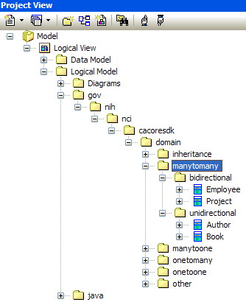
Figure 11 EA Project View Browser Showing SDK Sample Classes

Creating a Data Model Table
To add a Data Model (Table) class, follow these steps:
- In the EA Project Browser, select the Data Model package, as shown below:
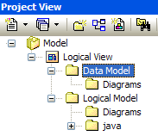
Figure 12 EA Data Model Package
In ArgoUML Explorer pane, select the Data Model package as shown below:
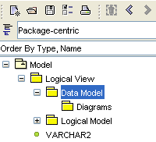
Figure 13 ArgoUML Data Model Package
NOTE: | Unlike object model classes that are created using a package hierarchy, all table classes should be created within the Data Model package.

- In EA, right click and select the Add | Add Element menu OR go to the Project | Add Element submenu.
In ArgoUML, new classes (tables) are added in the context of a class diagram within the selected package. If need be, click on a class diagram within the Data Model package to open/activate it, or create a new class diagram if none exists. Select the New Class icon found at the top of the diagram Editing pane then draw a new class within the diagram. This will effectively create a new class within the selected package. Alternatively, click on an existing class (table) within the selected package. The Property tab of the Detail pane will display the properties for the selected class. It will also display the New Class icon. Click on this icon.
- In EA, the Insert New Element dialog will appear, as shown below:
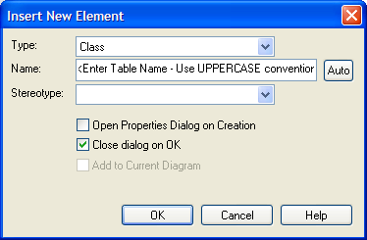
Figure 14 EA Insert New Element (Table) Dialog
In ArgoUML, the Properties tab in the Detail pane will become active for the new table (class).
- In EA, set the Insert New Element options as follows:
Insert New Element Option | Description
Type | Select Class as the element type from the drop down list.
Name | Enter a table name according to the Table naming conventions; i.e., table names should be all uppercase, with embedded words separated by an underscore (_).
Stereotype | Select table from the drop down list.
Open Property Dialog | Check the Open Property Dialog option if you want the Property dialog to open immediately after the table is created.
Close dialog on OK | Uncheck the Close dialog on OK option if you want to add multiple tables in one session.

NOTE: | Table names should follow Table naming conventions; i.e., table names should be all uppercase, with embedded words separated by an underscore (_). An example from the SDK sample model: UNDERGRADUATE_STUDENT.
In ArgoUML, enter a class name in the Name field of the Properties tab according to the Java class naming conventions; i.e., class names should start with a capital letter, with embedded words capitalized. Next, select the Data Model package from the Namespace drop down, as shown below:
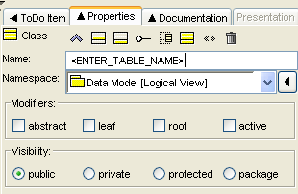
Figure 15 ArgoUML Table (Class) Properties Tab
Finally, click on the Stereotype tab, select the table Stereotype, and apply it to the new class by clicking the >> icon, as shown below:
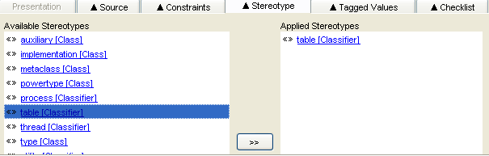
Figure 16 ArgoUML Applying a Stereotype to a Table Class
Alternatively, select the class within a diagram, right-mouse click to bring up the context menu, and then select the table Stereotype from the Apply Stereotypes sub-menu.
- In EA, click OK. If the Open Property Dialog was checked, the Property dialog will open up immediately after the class is created. The Property dialog for the SDK sample Credit table is shown below. Note that the Stereotype field is set to table:
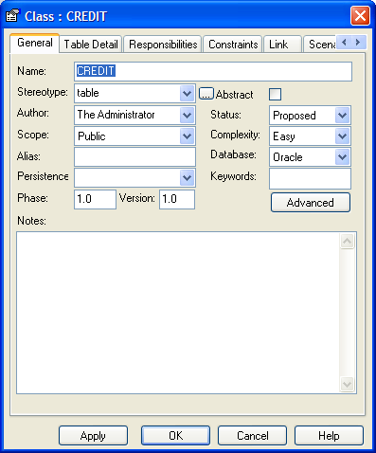
In ArgoUML, click the Save Project icon on the menu bar, or, alternatively, the Ctrl-S keys.
See section 1.3 Creating Attributes and Data Types for instructions on how to add attributes (columns) to tables.
- Repeat steps 1-5 as needed to add other tables. If the Close dialog on OK option was unchecked in the Insert New Element dialog, additional tables can be created in the Data Model package by repeating steps 4-5. The following diagram shows various tables that have been created in the Data Model package of the SDK sample model:
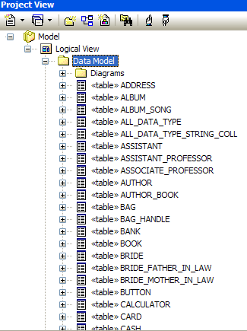
Figure 17 EA Various Tables from the SDK Sample Model

Creating Attributes and Data Types
UML Attribute elements are used to represent both Logical (Object) Model class attributes and Data Model table columns (class attributes). Both Logical Model and Data Model class attributes can be added/modified using the same process outlined below.
To add/modify a class or table attribute, follow these steps:
- Select the desired Logical Model class or Data Model table (class) element. The diagram below shows the Logical Model AllDataType class from the SDK sample model selected:
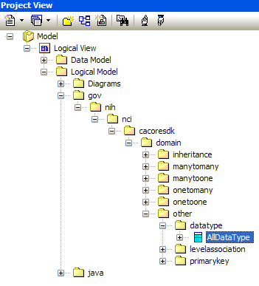
- In EA, right click and select the Attributes option from the menu OR go to the Element / Attributes menu option.
In ArgoUML, the Properties tab in the Detail pane will become active for the selected class. Click on the 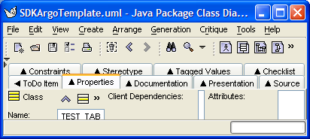 New Attribute icon.
Alternatively, select the class within a diagram, right-mouse click to bring up the context menu, and then select the New Attribute option from the Add sub-menu.
- In EA, the Attributes dialog will appear. Shown below is the Attributes dialog for the Logical Model AllDataType class from the SDK sample model. This class illustrates all of the available primitive data types (including primitive collections) that can be assigned to a class attribute:
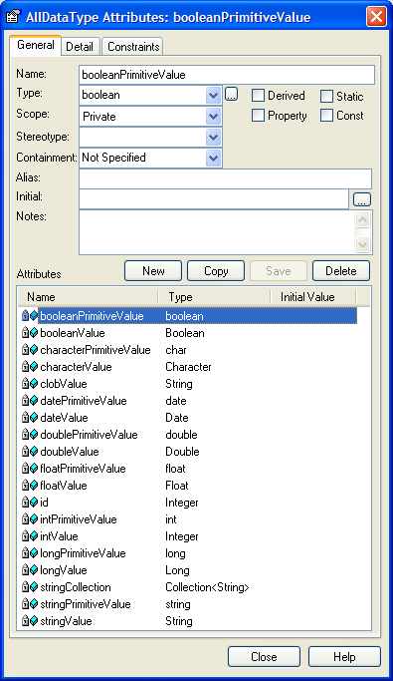
Figure 18 Sample AllDataType Class Showing Available Attribute Primitive Data Types
In ArgoUML, the Attribute properties tab will become active in the Detail pane, as shown below:
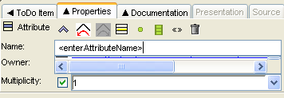
Figure 19 ArgoUML Attribute Properties Tab
- In EA, to add an attribute, click New, type an attribute name in the Name field, select a type from the Type drop down, and then click Save.
NOTE: | The SDK Code Generator is only concerned with the Name and Type fields. All other fields on the EA General tab of the Attributes dialog can be ignored (left default).  Also, the SDK Code generator understands both primitive wrapper class types (e.g. Boolean) and primitive types (e.g., boolean). If a particular data type is not shown in the drop down, it can be entered (typed) into the Type field.  For a list of the primitive attribute types understood by the SDK Code Generator, reference the AllDataType class in the SDK sample model (also shown in the diagram above). Note that primitive collection types (e.g., the stringCollection attribute of type Collection<String>) are also understood as an attribute type.
In ArgoUML, enter an attribute name in the Name field, and then select a type from the Type drop down. Click the Save Project icon on the menu bar, or, alternatively, the Ctrl-S keys to save the changes.
- To modify an attribute in EA, select it in the Attributes dialog, change the value of the Name and/or Type field, and then click Save.
To modify an attribute in ArgoUML, select the attribute in the Explorer pane by expanding the class to show its attributes, or click on the attribute name within the class in the Editing pane, if working with a diagram. The Attribute properties tab will become active for the attribute. Change the value of the Name and/or Type field. Click the Save Project icon on the menu bar, or, alternatively, the Ctrl-S keys to save the changes.

Working with Tag Values
The SDK Code Generator relies on information contained within custom Tag Values to generate particular system artifacts whenever the information needed cannot be derived from the UML model elements (Class, Attributes, and Associations) directly. Tag Values, for instance, are used to hold class/attribute documentation (comments and/or descriptions) while generating Java Docs for the object model. More importantly, however, Tag Values are used extensively when generating Hibernate Object Relational Mapping (.hbm.xml) files. Basically, it can be said that custom Tag Values are at the heart of the Logical (Object) Model-to-Data (Table) Model mapping process.
The SDK distribution provides a sample model (located within the \models directory) that demonstrates how various scenarios can be modeled through the use of custom Tag Values. Also, a reference table describing each of the various custom Tag Values and their usage is provided in section SDK Custom Tag Value Descriptions.
For those who may find that working directly with the Tag Values may be too cumbersome or error prone, please reference the caAdapter tool, which, among other capabilities, provides the ability to map object models to data models via a Graphical User Interface (GUI).

Adding/Modifying Tag Values
In EA, Tag Values attached to a particular UML element (such as a Class, Attribute, or Association) can be added/modified via the Tag Value browser, which is accessible by sequentially clicking and holding down the Ctrl-Shift-6 keys.
Given the following diagram from the SDK sample model which illustrates an association between the Employee and Project Logical Model classes:
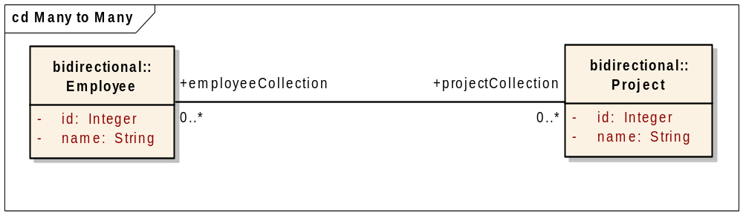
Figure 20 Employee-Project Asssociation Diagram
A sample of the Tag Value browser for the Association (line) between both classes is shown below:
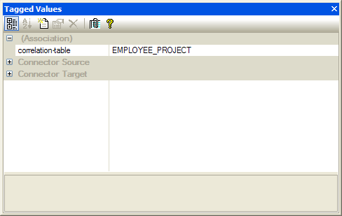
Figure 21 EA Tag Values Browser
Once the Tagged Values browser is open, selecting a particular UML element (such as a Class, Attribute, or Association) will cause the browser to display the corresponding Tag Values attached to the selected element.
In ArgoUML, Tag Values attached to a particular UML element (such as a Class, Attribute, or Association) can be added/modified by first selecting the element. This will cause the Detail pane to become active for the selected element. Next, click on the Tagged Values tab to activate it.
A sample of the Tagged Values tab for the Association between the Sample SDK Employee and Project Logical Model classes is shown below:
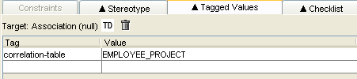
Figure 22 ArgoUML Detail Pane, Tagged Values Tab

SDK Custom Tag Value Descriptions
The following table lists the various Tag Values understood by the SDK Code Generator, and also describes when and where to use them:
Tag Value | Description
correlation-table | A Tag Value added to an Association element (line) drawn between two Logical Model classes within the same diagram. The value specifies the correlation (join) table name.  Given the following Many-to-Many relationship diagram:  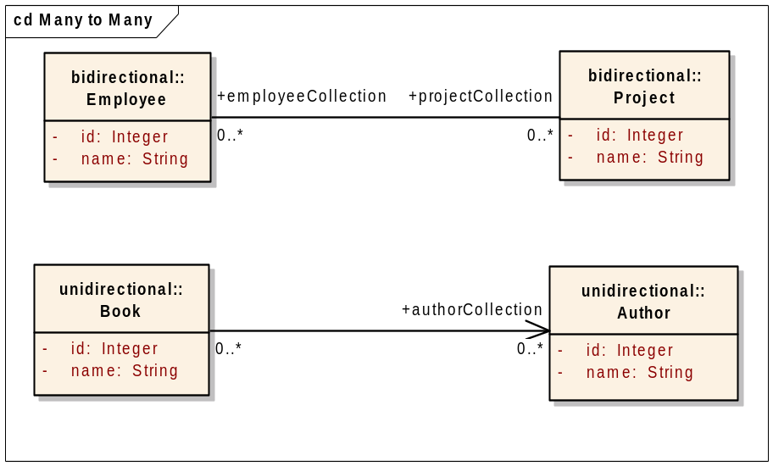  A couple of corresponding examples from the SDK sample model are provided in the table below:
  Logical Model Class (Source) | Logical Model Class (Target) | Tag Value (correlation-table)  Note: should be added to the Association (line) element
  Employee | Project | EMPLOYEE_PROJECT
  Book | Author | AUTHOR_BOOK
description | An optional Tag Value added to a Class or Attribute element to store documentation/comments for the element. The value describes the element, and is used when creating Java Docs for generated domain objects.  Note: The description Tag Value is only used if the documentation tag value for the element is empty or does not exist.
discriminator | A Tag Value added to a Data Model class Attribute element. The value of this tag represents the Logical Model class name that acts as the discriminator in situations when the parent and sub-class are persisted within the same database table. The value of the tag, if present, is placed within the discriminator element of the generated Hibernate mapping file.  A couple of examples from the SDK sample model is provided in the table below:
  Data Model Class (Table) | Data Model Attribute (Column) | Tag Value (discriminator)
  SHOES | DISCRIMINATOR | gov.nih.nci.cacoresdk.domain.inheritance.childwithassociation.sametable.Shoes
  GOVERNMENT | DEMOCRATIC_  DISCRIMINATOR | gov.nih.nci.cacoresdk.domain.inheritance.twolevelinheritance.sametable.DemocraticGovt
documentation | An optional Tag Value added to a UML element to store documentation/comments for the element. The value will be used when creating Java Docs for the generated domain object.  See also the documentation Tag Value.
id-attribute | A Tag Value added to a Logical Model class Attribute. The presence of the Tag Value indicates that the attribute is the class identifier attribute. This Tag Value is required when the identifier attribute is named something other than the default name, id. The value should specify the fully-qualified name of the Logical Model class that contains the attribute.  An example from the SDK sample model is provided in the table below:
  Logical Model Class Name | Logical Model Attribute Name | Tag Value (id-attribute)
  NoIdKey | myKey | gov.nih.nci.cacoresdk.domain.other.primarykey.NoIdKey
implements-association | A Tag Value added to a Data Model class Attribute (column). The value specifies the associated Logical Model class attribute that implements the association. The value must be specified using the following pattern: <fully-qualified logical model class name>.< attribute name>.  A couple of examples from the SDK sample model are provided in the table below:
  Data Model Class (Table) | Data Model Attribute (Column) | Tag Value (implements-association)
  CARD | SUIT_ID | gov.nih.nci.cacoresdk.domain.other.levelassociation.Card.suit
  ASSISTANT | PROFESSOR_ID | gov.nih.nci.cacoresdk.domain.inheritance.parentwithassociation.Assistant.professor
inverse-of | A Tag Value added to a Data Model class Attribute (column). Used to identify the inverse attribute (column) of a bi-directional association. The value specifies the corresponding inverse Logical Model class attribute, and must have the same value as the implements-association Tag Value of the bi-directional association. The value must be specified using the following pattern: <fully-qualified logical model class name>.< attribute name>.  Given the following Logical Model class diagram from the sample SDK model:  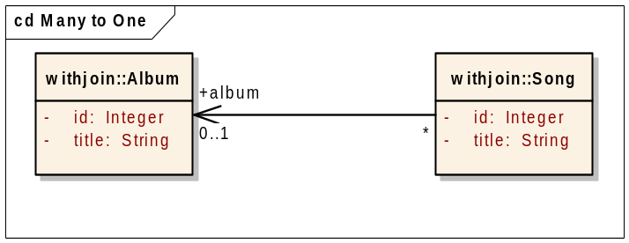  And the corresponding Data Model class diagram:  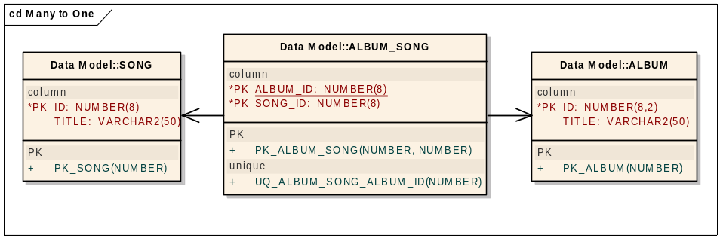  An example inverse-of Tag Value would be:  This indicates that the SONG_ID attribute (column) is the inverse side of the Song/Album bi-directional association implemented by album attribute of the Song class.  See also the related implements-association Tag Value.
  Data Model Class (Table) | Data Model Attribute (column) | Tag Value (inverse-of)
  ALBUM_  SONG | SONG_ID | gov.nih.nci.cacoresdk.domain.manytoone.unidirectional.withjoin.Song.album
  NOTE: | When adding an inverse-of value to a Data Model class Attribute for a Many-to-Many association, One-to-Many join table, Many-to-One join table, or a One to One - No Join Table scenario, make sure to supply the same value for both the implements-association and inverse-of Tag Values of the bi-directional association.
lazy-load | A Tag Value added to an Association element between two Logical Model classes. The value specifies whether the association should be fetched lazily or not.  Permissible values are yes, and no. That is, any value other than yes is treated as a no. Sets the lazy attribute in the generated .hbm.xml file to either true or false accordingly.  No example is provided in the SDK sample model.
mapped-attributes | A Tag Value added to a Data Model class Attribute (Column). The value specifies the corresponding mapped Logical Model class Attribute. The value must be specified using the following pattern: <fully-qualified logical model class name>.< attribute name>.  A couple of examples from the SDK sample model are provided in the table below:
  Data Model Class (Table) | Data Model Attribute (column) | Tag Value (mapped-attributes)
  UNDERGRADUATE_  STUDENT | STUDENT_ID | gov.nih.nci.cacoresdk.domain.inheritance.multiplechild.UndergraduateStudent.id
  SHOES | ID | gov.nih.nci.cacoresdk.domain.inheritance.childwithassociation.sametable.Shoes.id
mapped-collection-table | A Tag Value added to a Logical Model class Attribute. The value specifies the name of the mapped primitive collection (non-domain class – e.g., String, Integer) table.  Given the following Data Model class diagram from the SDK sample model:  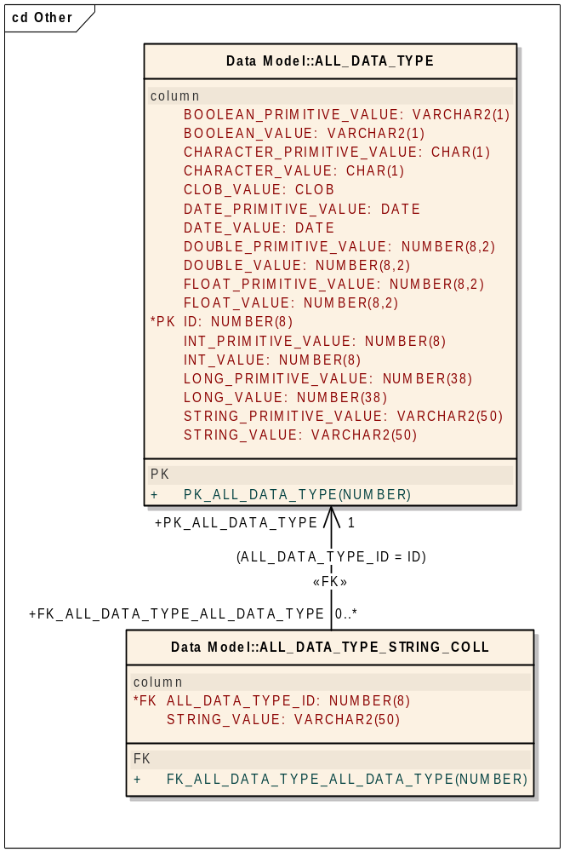  An example mapped-collection-table Tag Value would be:
  Logical Model Class | Logical Model Attribute | Tag Value (mapped-collection-table)
  AllDataType | stringCollection | ALL_DATA_TYPE_STRING_COLL
mapped-element | A Tag Value added to a Data Model class Attribute (Column). The value specifies the name of the mapped primitive collection (non-domain class – e.g., String, Integer) Logical Model class attribute. The value must be specified using the following pattern: <fully-qualified logical model class name>.< attribute name>.  Given the following Logical Model class diagram:  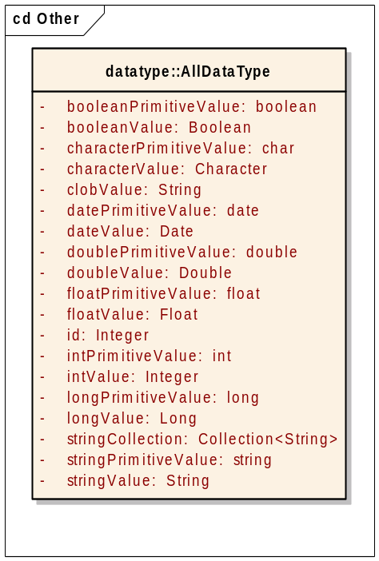  And the following Data Model class diagram from the SDK sample model:  An example mapped-collection-table Tag Value would be:
  Data Model Class (Table) | Data Model Attribute (Column) | Tag Value (mapped-element)
  ALL_DATA_  TYPE_STRING_COLL | STRING_VALUE | gov.nih.nci.cacoresdk.domain.other.datatype.AllDataType.stringCollection
type | A Tag Value added to a Data Model class Attribute (Column). The value specifies the DB column type. Valid values include (but are not limited to):  - CHAR  - CLOB  - NUMBER  - VARCHAR2  Several examples from SDK sample model include:
  Data Model Class (Table) | Data Model Attribute (Column) | Tag Value (mapped-element)
  CHARACTER_  PRIMITIVE_KEY | ID | CHAR
  CARD | IMAGE | CLOB
  UNDERGRADUATE_STUDENT | STUDENT_ID | NUMBER
  SHOES | COLOR | VARCHAR2

Exporting the UML Model to XMI (EA Only)
NOTE: | This section only applies to EA as the ArgoUML project is stored in an XML format that the SDK Code Generator can understand and process directly; i.e., the ArgoUML project file does not need to be exporting to XMI prior to processing it via the SDK Code Generator.

Before the SDK can process a UML model created within Enterprise Architect (EA), it needs to be exported to XMI and then copied to the \models directory within the SDK root folder.
To export a package to XMI, follow these steps:
- In the EA Project Browser, select the Logical View package, as shown below:
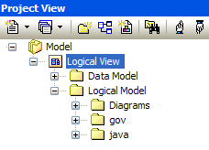
Figure 23 EA Logical View Package
- Right click and select the Import/Export menu OR go to the Project | Import/Export submenu. Select the Export Package to XMI option.
- The Export Package to XMI dialog will appear, as shown below:
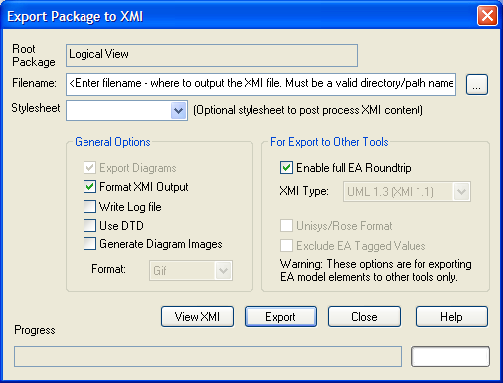
Figure 24 EA Exporting Package to XMI
- Set the Export options as follows:
NOTE: | The XMI export options that should be selected have changed for SDK 4.0. The new required options are:  - Export Diagrams  - Enable full EA Roundtrip

Export Option | Description
Filename | Used to indicate where to output the XMI file. Enter a valid directory/path name. Also, make sure the file type suffix is .xmi.
Stylesheet | Used to post-process XMI content before saving to file. Leave unselected.
Export Diagrams | Leave checked.
Use Unisys Rose Format | Used to indicate whether or not the Model should be exported in Rose UML 1.3, XMI 1.1 format. Leave unchecked.
Format XML output | Used to indicate whether or not to format output into readable XML (takes a few additional seconds at end of run). Leave checked.
Write log file | Used to indicate whether or not a log of export activity should be created (recommended). The log file will be saved in the same directory exported to. Optional. Leave checked if desired.
Use DTD | Used to indicate whether or not to use the UML1.3 DTD. Using this option will validate the correctness of the model and that no syntactical errors have occurred. Leave unchecked.
Exclude EA Tagged Values | Used to indicate whether or not EA specific information should be excluded from the export to other tools. The SDK now supports Full EA roundtrip. Leave unchecked.

- Press Export.
- Once the XMI file has been exported, copy it to the \models directory within the SDK root folder.
NOTE: | The XMI file name and the value of the MODEL_FILE property within the deploy.properties file must match. Otherwise, a File Not Found error will be reported when trying to process the XMI file through the SDK Code Generator.

Importing XMI into the UML Model (EA Only)
NOTE: | This section only applies to EA as the ArgoUML project is stored in an XML format that the SDK Code Generator can understand and process directly; i.e., the ArgoUML project file does not need to be exporting to XMI prior to processing it via the SDK Code Generator.

The SDK now supports the processing of XMI that was exported using the full EA roundtrip option. Some organizations may have the need to modify the exported XMI file, perhaps to add Tag Values. As long as the XMI was exported using the roundtrip option, it can be synchronized with the UML model by importing it back into EA.
NOTE: | The selection of the incorrect import options may corrupt the model file.  Make sure to backup the original model file prior to importing XMI back into the UML model!!!

To import an XMI package back into EA, follow these steps:
- In the EA Project Browser, select the Logical View package, as shown below:
Figure 25 EA Logical View Package
- Right click and select the Import/Export menu OR go to the Project | Import/Export submenu. Select the Import Package from XMI option.
- The Import Package from XMI dialog will appear, as shown below:
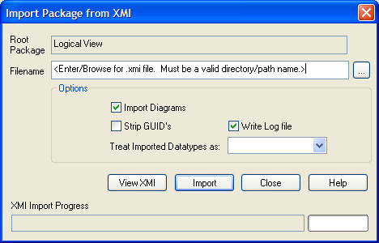
Figure 26 EA Import Package from XMI
- Set the Import options as follows:
Import Option | Description
Filename | Used to indicate where to import the XMI file. Enter a valid directory/path name.
Import Diagrams | Make sure to leave checked!!!
Strip GUIDS | Used to remove Universal Identifier information from the file on import. This permits the import of a package twice into the same model - the second import will require new GUIDS to avoid element collisions. Make sure to leave unchecked!!!
Treat Imported Datatypes as | Leave unselected.
Write log file | Used to indicate whether or not a log of export activity should be created (recommended). The log file will be saved in the same directory exported to. Optional. Leave checked if desired.

- Click Import.
- A confirmation dialog will appear, as shown below:
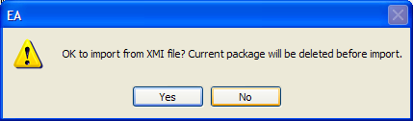
Figure 27 EA Confirm XMI File Import Dialog
- Click Yes. The XMI file will now be imported back into EA, and the XMI and UML model will be synchronized.

See http://en.wikipedia.org/wiki/Model-driven_architecture for more information on Model-Driven Architecture software design approach.
See http://argouml-stats.tigris.org/documentation/manual-0.24/ch11.html for more information on the ArgoUML Explorer pane.
See http://argouml-stats.tigris.org/documentation/manual-0.24/ch13s03.html for more information on the ArgoUML Detail Pane, Properties tab.
See http://argouml-stats.tigris.org/documentation/manual-0.24/ch12.html for more information about the Editing pane.
See http://argouml-stats.tigris.org/documentation/manual-0.24/ch12.html for more information about the Editing pane.
For more information regarding the caAdapter tool/project, see http://trials.nci.nih.gov/projects/infrastructureProject/caAdapter.
The <discriminator> element is required for polymorphic persistence using the table-per-class-hierarchy mapping strategy and declares a discriminator column of the table. The discriminator column contains marker values that tell the persistence layer what subclass to instantiate for a particular row. See http://www.hibernate.org/hib_docs/v3/reference/en/html_single/#mapping-declaration-discriminator for more information.

